NAME: OGUNJIMI TIMILEYIN GIDEON

MATRIC NUMBER: 222492

CSC 235 ASSIGNMENT 1

GITHUB LINK: <https://github.com/drixesxs>

THE UNIX OPERATING SYSTEM (LINUX)

Linux is a community of open-source operating system that is based on the Linux kernel. Linus Torvalds is regarded as the Father of Linux because Linux was firstly released on September 17, 1991 by him.

As a result of the open-source nature of Linux. Its source code can be revised and dispersed to anyone under the GNU license. Linux was originally made for personal computers but today is used in routers, consoles, smartwatches and the biggest feat of Linux- Android.

A Linux distribution is a Linux operating system (based on the Linux kernel) made from a diversity of software and a package management system that takes care of updating software and installing new software. Examples of Linux distribution are: openSUSE, CentOS, Fedora Linux (Red Hat), Kali Linux, Arch Linux, Ubuntu, Debian just to name a few.

SOFTWARE FUNCTIONAL REQUIREMENTS

Software functional requirements describes the services a software must provide in order to fulfil its purpose. For example, an online shopping software must have the following functional requirements:

1. The software must allow users to create an account with an email and a password.
2. The software must allow users to login using their email and password.
3. The software must have a payment mechanism to allow users to pay for an order before placing the order.
4. The software must send a confirmation email whenever an order is placed.
5. The software must allow users to add a phone number and an address that allows them to be contacted about delivery of their order.
6. In case of a forgotten password, the software must allow users to reset the password by clicking on “Forgotten password” option and receiving a link to their verified email address.

WHY UNIX IS USUALLY PREFERRED

Unix systems are proposed to be more reliable and faster than other operating systems with fewer downtimes or crashes. Furthermore, Unix is faster because its individual software are lightweight and fewer processes run in the background than in Windows.

WHY UNIX IS REFERRED AS THE SCIENTIST O.S

Scientists deal with computing a lot; hence Unix systems are preferred because they are faster at computing than other operating systems. Supercomputers for example are mostly used for scientific purposes and most supercomputers utilize the Linux operating system (UNIX). Additionally, High-Performance Linux clusters is a high-performance computing technology used in supercomputers that is available only in Linux. Unix systems also provide more flexibility and availability than any other operating system.

WHAT TYPE OF PROGRAMMING LANGUAGE IS C?

C is a mid-level, compiler-based, procedure-oriented programming language. It is not an Object-Oriented-Programming Language.

STRUCTURE OF A C PROGRAM

1. **#include <stdio.h>** (Preprocessor Command/Header): This includes all standard input-output files before compiling any C program.
2. **Int main ()** (Function): This main() function starts the execution of the C program.
3. **{** (Opening Curly bracket): This indicates the beginning of the main function. Code is written within this brace to get executed.
4. **return 0**: This Command ends the C program and returns a null value (0) to signify that the program ran successfully without any error.
5. **}** (Closing Curly bracket): This indicates the end of the main () function.

HOW TO CREATE A C PROGRAMMING FILE ON LINUX OS

1. Install an IDE, e.g. Visual Studio Code.
2. Open Visual Studio Code.
3. Click File option



1. Select New Text File
2. Click on Select a Language

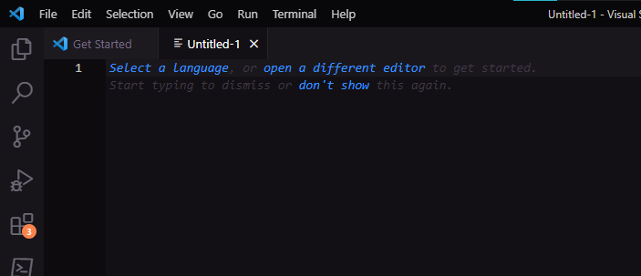



1. Search for C programming Language and select it

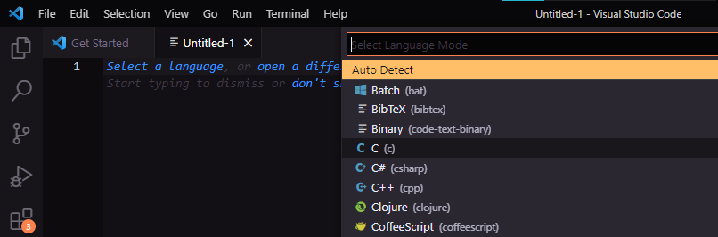



The file is now a C programming file.